**MAVEN INSTALLATION**

### Step 1: Download Maven Zip File and Extract

### Click on the appropriate link to download the binary zip archive of the latest version of Maven.

### 

### 

### Step 2: Add MAVEN_HOME System Variable

### 

**STEP 3: Click the new button under the System variables section to add a new system environment variable.**

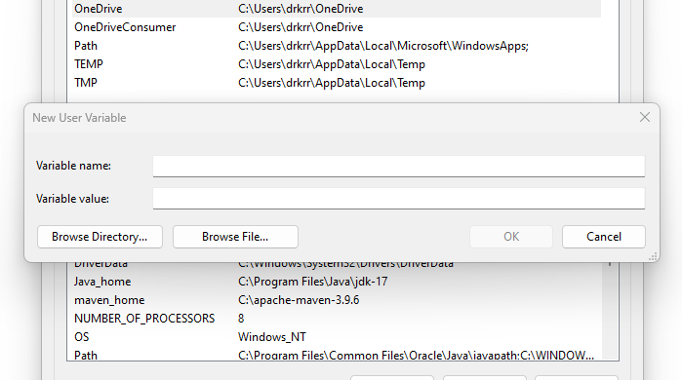

**STEP 4: Enter Maven as the variable name and the path to the Maven directory as the variable value.**

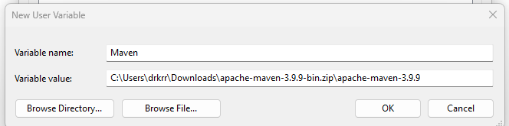

**STEP 5: Select the Path variable under the System variables section in the Environment Variables window**

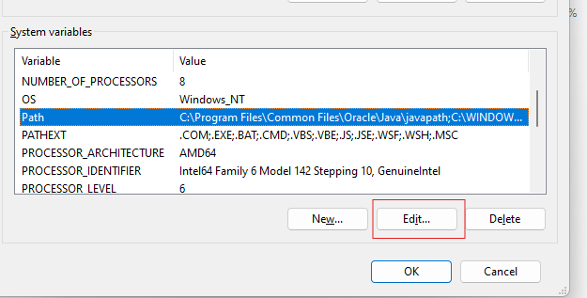

**STEP 6: Enter %MAVEN_HOME%\bin in the new field. Click ok to save changes to the Path variable.**

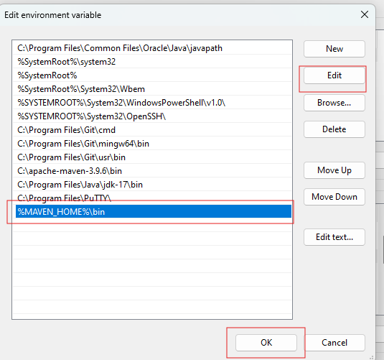

### STEP 7: Verify Maven Installation

